OILS ON CANVAS
With KATHLEEN LAGASSE
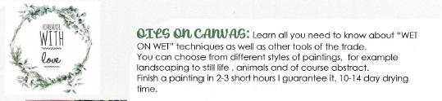
WHEN: Sunday, June 5 at 2:00 pm til 5:00 pm
Please arrive by 1:45
WHERE: WASKADA ARENA
COST: $65.00 PER PARTICIPANT, MINIMUM 6 PARTICIPANTS
Deadline to register is May 31
Please call Municipality of Brenda Waskada Office to Register
204-673-2401
