Do you know what goes on behind your neighbor’s front door??
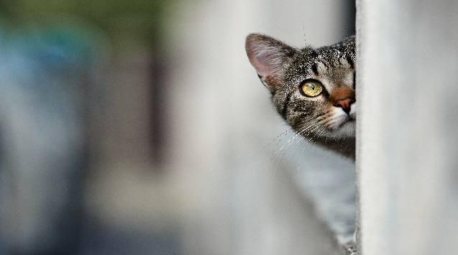

Do you have a craft or hobby you would like to share with a group of people?
Knitting, Crocheting, Painting, Flower Arranging, Woodwork, Leather Tooling, Metal Work, Gardening, Cake Decorating, Baking, Smoker Recipes, Chaulking, Stained Glass -
The list is endless!
Let’s meet once a month (or more) to learn about your interest that you would love to showcase!
Please call the Municipal Office 204-673-2401 or stop in to discuss

Look forward to hearing about the next great project!

