WATER CONSERVATION TIPS FOR HOUSEHOLDS
• Never use your toilet as a wastebasket. Check the flapper in your toilet tank to see if it goes down. Repair leaky toilets. Add 12 drops of food coloring into the tank, and if color appears in the bowl one hour later, your toilet is leaking. A leak of one water drop/second wastes 10,000 liters of water/year.

• Do not let the water run while soaping, shampooing, shaving, or brushing your teeth. Fill the sink to shave.

• Take short showers instead of tub baths. Reducing a 10-minute shower to 5 minutes will save 12.5 gallons of water (47.3 liters) if the showerhead has a flow rate of 2.5 gallons (9.5 liters) per minute, and even more with a higher flow rate.

• Before pouring water down the drain, consider other uses for it, such as watering plants or gardens.
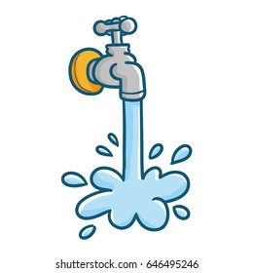

• Keep drinking water in the refrigerator instead of letting the faucet run until the water is cool.
- Repair leaky faucets, indoors and out.
• Wash fruits and peel vegetables in a basin of water.

• Use a vegetable brush to clean produce.

• Do not use water to defrost frozen foods; thaw them in the refrigerator overnight.

• Use a dishpan for washing and rinsing dishes.

• Add food waste to your compost pile instead of using the garbage disposal and running water to rinse.

• Operate the dishwasher only when completely full. Consider using the ‘light-wash’ option.
- If washing dishes by hand, fill the sink with water rather than continually running the tap.
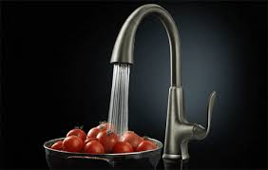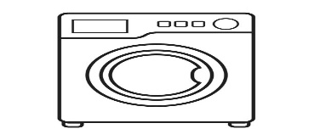
BE WATER-WISE,
CONSERVE WATER
• Use the appropriate water level or load size selection on the washing machine.

• Wash full loads of clothes whenever possible.

• Sweep driveways, sidewalks, decks, porches, and steps rather than hosing them off.

• Wash the car from a bucket or consider using a commercial car wash that recycles water.

• When using a hose, control the flow with an automatic shutoff nozzle.

• Avoid purchasing water toys that require a constant stream of water.

• If you have one, lower the water level in your pool to reduce the amount of water that splashes out.

• Use a pool cover to reduce evaporation when the pool is not in use.
- Add mulch, organic matter, or compost to soil to prevent water loss through evaporation. This aids to promote plant growth and control weeds.

- Set mower blades 2-3 inches high. Longer grass shades the soil improving moisture retention, has more leaf surface to take in sunlight, allowing it to grow thicker and develop a deeper root system. This helps grass survive drought, tolerate insect damage, and fend off disease.

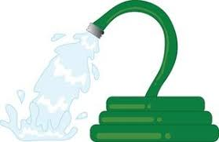

USING WATER WISELY RURALLY

• Using clean treated water in your field sprayer
- Fill your tank from the hose overnight.
- You can make or purchase a float control that will turn off the water when your tank is full.
- You will help to take a lot of pressure off the rural pipeline system and be ready to go to the field earlier. The big demand means water treatment plants are running at maximum capacity.
- Farm water conservation and management is absolutely critical if your water supply system is to keep up with the water that you and your neighbors need.
• Livestock operations that use treated water should always operate from their own reservoir.
  - You should fill the reservoir over a 24-hour period and repressurize to meet your barn’s requirements.
  - You need a minimum 24-hour back-up water supply in case your municipal system has a breakdown.
  - By filling to a reservoir, you help to reduce peak demands and save dollars.

